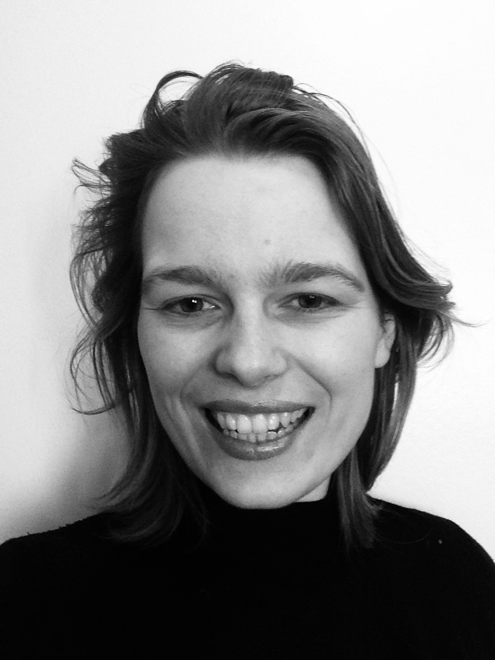
CV - Roos Holleman

Contact

Nyelandsvej 18, 3.TV
2000, Frederiksberg
+45 61 31 89 28
roosholleman@gmail.com
www.roosholleman.nl (under construction)
@roosholleman on instagram

Born 1989 in Tilburg, the Netherlands.
Lives and works in Copenhagen, Denmark.

Education
- BFA - AKV/ St. Joost Academy Breda, NL 2012

Selected solo exhibitions

2021
- Birds Of A Petal - Eksrummet, Copenhagen
- Dressed For Paradise - Grote Kerk, Alkmaar
2020
- Wallacea - Het Natuurhistorisch, Rotterdam
2019
- Roos Holleman - Castellvm Aqvae, Bloemendaal
- An Inordinate Fondness - Luycks Gallery, Tilburg
2016
- Museum Mythologies - Godsbanen, Aarhus
2015
- Still Lives Without Swagger - Janknegt Gallery, Laren
- Natuurschatten - Natuurhistorisch Museum, Tilburg

Selected group shows

2022
- Kunstnernes Påskeudstilling - Kunsthal, Aarhus
- Revealing The Unseen, with Jacobien de Rooij - Castellvm Aqvae, Bloemendaal
2021
- Vanwege Vincent - Stedelijk Museum, Breda
- Suspended Hue, with HIdenori Mitsue - Janknegt Gallery, Laren
2020
- Animalia - Coda Museum, Apeldoorn
- Nature In The House - Kunsthandel P. De Boer, Amsterdam
2019
- Sign Of The Times - Museum Jan Cunen, Oss
- The Trees Are Inviting The Wind - Willem Twee Kunstruimte, Den Bosch
2018
- Tapis Volant - Galerie la Ferronnerie, Paris
- De Aard Der Dingen - Rijksmuseum Twenthe, Enschede
2017
- Apperances - Galerie la Ferronnerie, Paris
2016
- Prospects & Concepts - Van Nellefabriek, Rotterdam

- Calculation - Kurgan Regional Art Museum, Kurgan
- TO THE ZOO - Kers Gallery, Amsterdam

2015
- Gestold Leven, with Matthias Schaareman - Luycks Gallery, Tilburg
2014
- Nordkraftudstillingen - Kunsthal Nord, Aalborg
2013
- Beeldrijm - Museum Arnhem, Arnhem

Residencies & Stipends

- Aros Kunstmuseum, Aarhus 2017
- Tækker AiR, Berlin 2016, 2018
- Vincent van Goghhuis, Zundert 2014
- De Fabriek, Eindhoven 2012, 2014
- Mondrian Fund Stipend, 2014

Selected art fairs

- Art On Paper - solo presentation, New York
- PAN, Amsterdam
- Art On Paper - Amsterdam
- Volta - solo presentation, Basel
- Drawing Now - solo presentation, Paris

Publications
2020
- WALLACEA, with Alexander Reeuwijk - Noordboek publishing, Gorredijk
2019
- The Centre of Attention - Monograph, 99 Publishers, Haarlem

Selected collections

- 21C Museum Hotel, Louisville
- Coda Museum, Apeldoorn
- Het Natuurhistorisch, Rotterdam
- Centraal Museum, Utrecht
- Museum Arnhem, Arnhem
- Natuurmuseum, Brabant
- Vincent van Gogh Huis, Zundert
- Private collections in Europe and the US

